Experiment -7
Student Name: Ayush  Branch: BE-CSE  Semester:6th  Subject Name: Project Based Learning in Java with Lab | UID:22BCS15510  Section/Group:IOT_608/A  Date of Performance:17/03/2025  Subject Code: 22CSH-359

7.1.1.Aim: Create a Java program to connect to a MySQL database and fetch data from a single table. The program should: Use DriverManager and Connection objects. Retrieve and display all records from a table named Employee with columns EmpID, Name, and Salary..

7.1.2Objective: To develop a Java program that connects to a MySQL database, retrieves data from the Employee table, and displays all records, demonstrating basic JDBC connectivity and data retrieval operations.

7.1.3 Code:
import java.sql.*;

public class FetchEmployeeData { public static void main(String[] args) {
String url = "jdbc:mysql://localhost:3306/testdb";
String user = "root";
String password = "password";

String query = "SELECT EmpID, Name, Salary FROM Employee";

try {
// Load MySQL JDBC driver
Class.forName("com.mysql.cj.jdbc.Driver");

// Establish connection
Connection con = DriverManager.getConnection(url, user, password); System.out.println("Connected to the database!");

// Create statement and execute query
Statement stmt = con.createStatement();
ResultSet rs = stmt.executeQuery(query);

// Display results
System.out.println("\nEmployee Records:"); System.out.println("--------------------------------------");
System.out.printf("%-10s %-20s %-10s%n", "EmpID", "Name", "Salary");
System.out.println("--------------------------------------");

while (rs.next()) { int empID = rs.getInt("EmpID"); String name = rs.getString("Name"); double salary = rs.getDouble("Salary");

System.out.printf("%-10d %-20s %-10.2f%n", empID, name, salary);
}

// Close resources
rs.close(); stmt.close();
con.close();
System.out.println("\nConnection closed.");

} catch (ClassNotFoundException e) {
System.out.println("MySQL Driver not found: " + e.getMessage());
} catch (SQLException e) {
System.out.println("SQL Error: " + e.getMessage());
}
} }
7.1.4 Output:
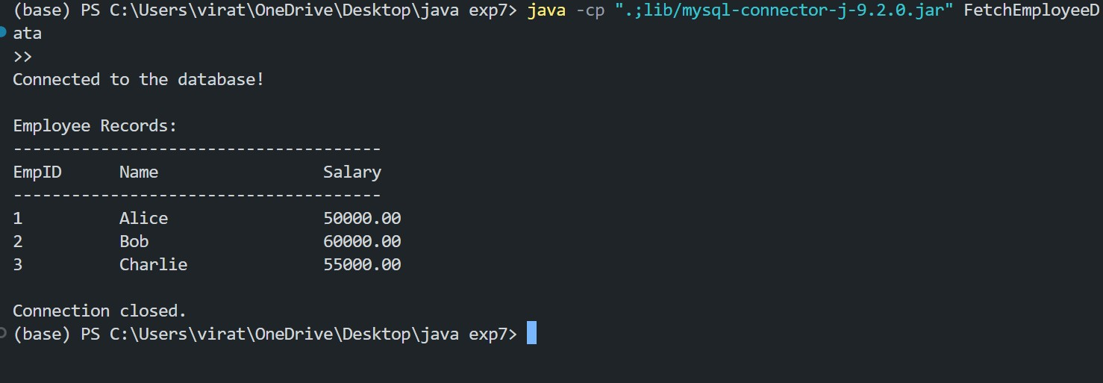

7.2.1Aim:Build a program to perform CRUD operations (Create, Read, Update, Delete) on a database table Product with columns: ProductID, ProductName, Price, and Quantity. The program should include: Menu-driven options for each operation. Transaction handling to ensure data integrity.
7.2.2Objective: To develop a Java program that connects to a MySQL database and performs CRUD operations (Create, Read, Update, Delete) on the Product table. The program ensures data integrity by using transaction handling and provides a menu-driven interface for user-friendly interaction.

7.2.3Code:

import java.sql.*;
import java.util.Scanner;

public class ProductCRUD {

private static final String URL = "jdbc:mysql://localhost:3306/ProductDB"; private static final String USER = "root"; private static final String PASSWORD = "password";

public static void main(String[] args) { Scanner scanner = new Scanner(System.in);

try (Connection conn = DriverManager.getConnection(URL, USER, PASSWORD)) {
Class.forName("com.mysql.cj.jdbc.Driver");
System.out.println("Connected to the database!");

boolean exit = false;

while (!exit) {
System.out.println("\n=== Product CRUD Operations ===");
System.out.println("1. Create Product");
System.out.println("2. Read Products");
System.out.println("3. Update Product");
System.out.println("4. Delete Product");
System.out.println("5. Exit");
System.out.print("Choose an option: ");

int choice = scanner.nextInt();
scanner.nextLine(); switch (choice) {
case 1 -> createProduct(conn, scanner); case 2 -> readProducts(conn); case 3 -> updateProduct(conn, scanner); case 4 -> deleteProduct(conn, scanner);
case 5 -> exit = true;
default -> System.out.println("Invalid option. Try again.");
}
}

} catch (ClassNotFoundException e) {
System.out.println("MySQL Driver not found: " + e.getMessage());
} catch (SQLException e) {
System.out.println("SQL Error: " + e.getMessage());
}

scanner.close();
}

private static void createProduct(Connection conn, Scanner scanner) throws SQLException {
System.out.print("Enter product name: ");
String name = scanner.nextLine(); System.out.print("Enter price: "); double price = scanner.nextDouble(); System.out.print("Enter quantity: "); int quantity = scanner.nextInt();

String query = "INSERT INTO Product (ProductName, Price, Quantity) VALUES (?, ?, ?)";

try (PreparedStatement pstmt = conn.prepareStatement(query)) { conn.setAutoCommit(false);

pstmt.setString(1, name); pstmt.setDouble(2, price); pstmt.setInt(3, quantity);
int rows = pstmt.executeUpdate(); conn.commit();
System.out.println(rows + " product(s) inserted successfully!");
} catch (SQLException e) {
conn.rollback();
System.out.println("Transaction rolled back due to error: " + e.getMessage());
} finally {
conn.setAutoCommit(true);
}
}

private static void readProducts(Connection conn) throws SQLException { String query = "SELECT * FROM Product";

try (Statement stmt = conn.createStatement(); ResultSet rs = stmt.executeQuery(query)) {

System.out.println("\nProduct Records:");
System.out.println("--------------------------------------------------");
System.out.printf("%-10s %-20s %-10s %-10s%n", "ProductID", "ProductName", "Price", "Quantity");
System.out.println("--------------------------------------------------");

while (rs.next()) {
int id = rs.getInt("ProductID");
String name = rs.getString("ProductName"); double price = rs.getDouble("Price"); int quantity = rs.getInt("Quantity");

System.out.printf("%-10d %-20s %-10.2f %-10d%n", id, name, price, quantity);
}
}
}

private static void updateProduct(Connection conn, Scanner scanner) throws SQLException {
System.out.print("Enter product ID to update: "); int id = scanner.nextInt();
scanner.nextLine();

System.out.print("Enter new name: ");
String name = scanner.nextLine();
System.out.print("Enter new price: ");
double price = scanner.nextDouble();
System.out.print("Enter new quantity: "); int quantity = scanner.nextInt();

String query = "UPDATE Product SET ProductName = ?, Price = ?, Quantity = ? WHERE ProductID = ?";

try (PreparedStatement pstmt = conn.prepareStatement(query)) { conn.setAutoCommit(false);

pstmt.setString(1, name); pstmt.setDouble(2, price); pstmt.setInt(3, quantity); pstmt.setInt(4, id);

int rows = pstmt.executeUpdate(); conn.commit();

System.out.println(rows + " product(s) updated successfully!");

} catch (SQLException e) { conn.rollback();
System.out.println("Transaction rolled back due to error: " + e.getMessage());
} finally {
conn.setAutoCommit(true);
}
}

private static void deleteProduct(Connection conn, Scanner scanner) throws SQLException {
System.out.print("Enter product ID to delete: "); int id = scanner.nextInt();

String query = "DELETE FROM Product WHERE ProductID = ?";

try (PreparedStatement pstmt = conn.prepareStatement(query)) {
conn.setAutoCommit(false);
pstmt.setInt(1, id);
int rows = pstmt.executeUpdate(); conn.commit();
System.out.println(rows + " product(s) deleted successfully!");
} catch (SQLException e) { conn.rollback();
System.out.println("Transaction rolled back due to error: " + e.getMessage());
} finally {
conn.setAutoCommit(true);
}
}
}

7.2.4Output:
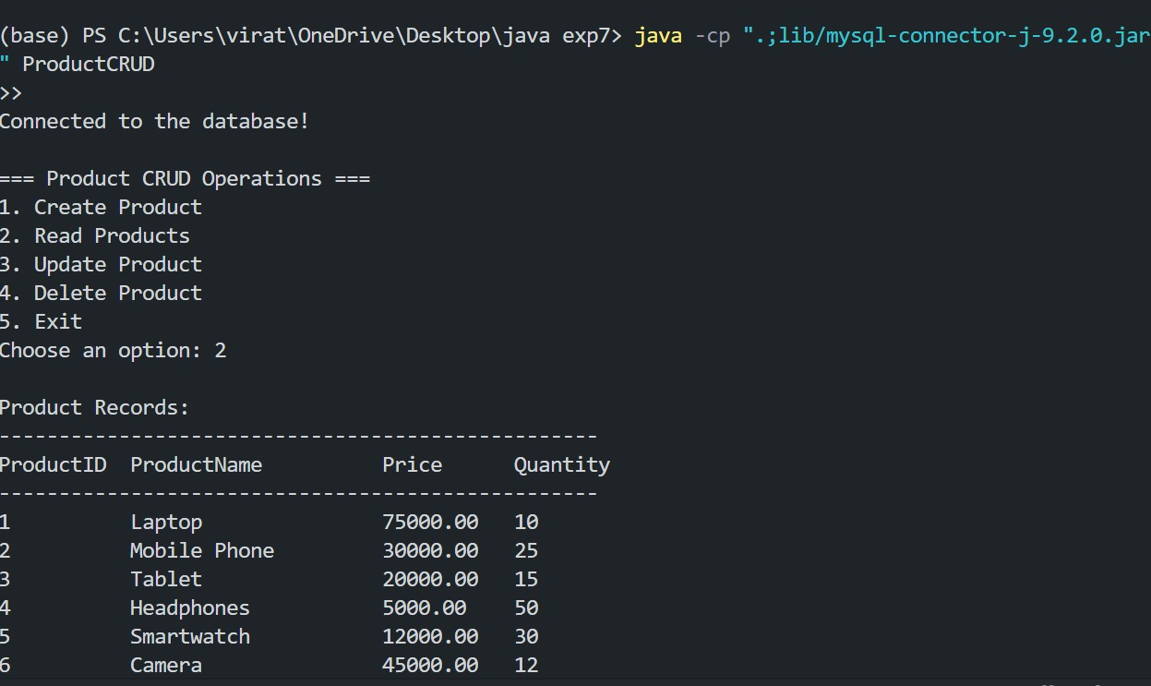
7.3.1Aim: Develop a Java application using JDBC and MVC architecture to manage student data. The application should: Use a Student class as the model with fields like StudentID, Name, Department, and Marks. Include a database table to store student data. Allow the user to perform CRUD operations through a simple menu-driven view. Implement database operations in a separate controller class.
7.3.2Objective:The objective of this program is to develop a menu-driven Java application that allows users to add employee details, display all stored employees, and exit the program. Employee details, including ID, name, designation, and salary, are stored persistently in a file using serialization.
7.3.3Code:
StudentController.java package controller;

import model.Student; import java.sql.*; import java.util.ArrayList;
import java.util.List;

public class StudentController {

private static final String URL = "jdbc:mysql://localhost:3306/StudentDB"; private static final String USER = "root";
private static final String PASSWORD = "rishuraman1@V";

// Method to create a new student
public void createStudent(Student student) throws SQLException {
String query = "INSERT INTO Student (Name, Department, Marks) VALUES (?, ?, ?)";

try (Connection conn = DriverManager.getConnection(URL, USER, PASSWORD); PreparedStatement pstmt = conn.prepareStatement(query)) {

pstmt.setString(1, student.getName()); pstmt.setString(2, student.getDepartment()); pstmt.setDouble(3, student.getMarks());
pstmt.executeUpdate();
System.out.println("Student added successfully!");
}
}
// Method to retrieve all students
public List<Student> getAllStudents() throws SQLException {
List<Student> students = new ArrayList<>();
String query = "SELECT * FROM Student";

try (Connection conn = DriverManager.getConnection(URL, USER, PASSWORD);
Statement stmt = conn.createStatement();
ResultSet rs = stmt.executeQuery(query)) {

while (rs.next()) { students.add(new Student( rs.getInt("StudentID"), rs.getString("Name"), rs.getString("Department"),
rs.getDouble("Marks")
));
}
}
return students;
}

// Method to update student data
public void updateStudent(Student student) throws SQLException {
String query = "UPDATE Student SET Name = ?, Department = ?, Marks = ? WHERE StudentID = ?";

try (Connection conn = DriverManager.getConnection(URL, USER, PASSWORD); PreparedStatement pstmt = conn.prepareStatement(query)) {

pstmt.setString(1, student.getName()); pstmt.setString(2, student.getDepartment()); pstmt.setDouble(3, student.getMarks()); pstmt.setInt(4, student.getStudentID());

int rows = pstmt.executeUpdate();
if (rows > 0) {
System.out.println("Student updated successfully!");
} else {
System.out.println("Student not found.");
}
}
}
// Method to delete a student public void deleteStudent(int studentID) throws SQLException {
String query = "DELETE FROM Student WHERE StudentID = ?";

try (Connection conn = DriverManager.getConnection(URL, USER, PASSWORD); PreparedStatement pstmt = conn.prepareStatement(query)) {

pstmt.setInt(1, studentID); int rows = pstmt.executeUpdate();
if (rows > 0) {
System.out.println("Student deleted successfully!"); } else {
System.out.println("Student not found.");
}
}
}
}

Student.java

package model;

public class Student { private int studentID; private String name; private String department; private double marks;

public Student(int studentID, String name, String department, double marks) { this.studentID = studentID; this.name = name; this.department = department; this.marks = marks;
}

// Getters and Setters public int getStudentID() { return studentID;
}
public void setStudentID(int studentID) {
this.studentID = studentID;
}
public String getName() {
return name;
}

public void setName(String name) {
this.name = name;
}

public String getDepartment() {
return department;
}

public void setDepartment(String department) {
this.department = department;
}

public double getMarks() {
return marks;
}

public void setMarks(double marks) {
this.marks = marks;
}

@Override public String toString() {
return String.format("ID: %d, Name: %s, Dept: %s, Marks: %.2f", studentID, name, department, marks);
}
}

StudentView.java

package view;

import controller.StudentController; import model.Student;

import java.util.List;
import java.util.Scanner;

public class StudentView {

private static final Scanner scanner = new Scanner(System.in);
private static final StudentController controller = new StudentController();

public void displayMenu() {
boolean exit = false;

while (!exit) {
System.out.println("\n=== Student Management System ===");
System.out.println("1. Add Student");
System.out.println("2. View All Students");
System.out.println("3. Update Student");
System.out.println("4. Delete Student");
System.out.println("5. Exit");
System.out.print("Choose an option: ");

int choice = scanner.nextInt();
scanner.nextLine(); // Consume newline

try {
switch (choice) { case 1 -> addStudent(); case 2 -> viewStudents(); case 3 -> updateStudent(); case 4 -> deleteStudent(); case 5 -> exit = true;
default -> System.out.println("Invalid option. Try again.");
}
} catch (Exception e) {
System.out.println("Error: " + e.getMessage());
}
}
scanner.close();
}
private void addStudent() throws Exception {
System.out.print("Enter name: ");
String name = scanner.nextLine();
System.out.print("Enter department: ");
String department = scanner.nextLine();
System.out.print("Enter marks: "); double marks = scanner.nextDouble();

Student student = new Student(0, name, department, marks);
controller.createStudent(student);
}
private void viewStudents() throws Exception { List<Student> students = controller.getAllStudents();
System.out.println("\nStudents List:"); for (Student student : students) {
System.out.println(student);
}
}
private void updateStudent() throws Exception { System.out.print("Enter student ID to update: ");
int id = scanner.nextInt();
scanner.nextLine();

System.out.print("Enter new name: ");
String name = scanner.nextLine();
System.out.print("Enter new department: ");
String department = scanner.nextLine(); System.out.print("Enter new marks: ");
double marks = scanner.nextDouble();

Student student = new Student(id, name, department, marks);
controller.updateStudent(student);
}

private void deleteStudent() throws Exception { System.out.print("Enter student ID to delete: ");
int id = scanner.nextInt();
controller.deleteStudent(id);
}
}
MainApp.java import view.StudentView;

public class MainApp {
public static void main(String[] args) { StudentView view = new StudentView(); view.displayMenu();}}

7.3.4Output:
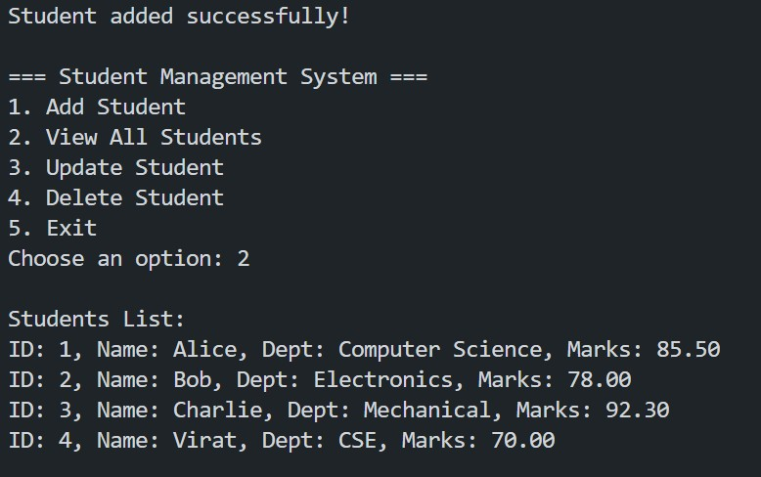

Learning Outcomes:
- Understanding JDBC Integration:Gained practical experience in integrating JDBC with a Java application for database connectivity.
- MVC Architecture Implementation:Learned how to implement the ModelView-Controller (MVC) architecture in Java for better code organization and separation of concerns.
- Database CRUD Operations:Acquired the ability to perform CRUD operations (Create, Read, Update, Delete) using SQL queries in Java applications.
- Transaction Handling:Understood the importance of transaction handling for maintaining data integrity during database operations.

